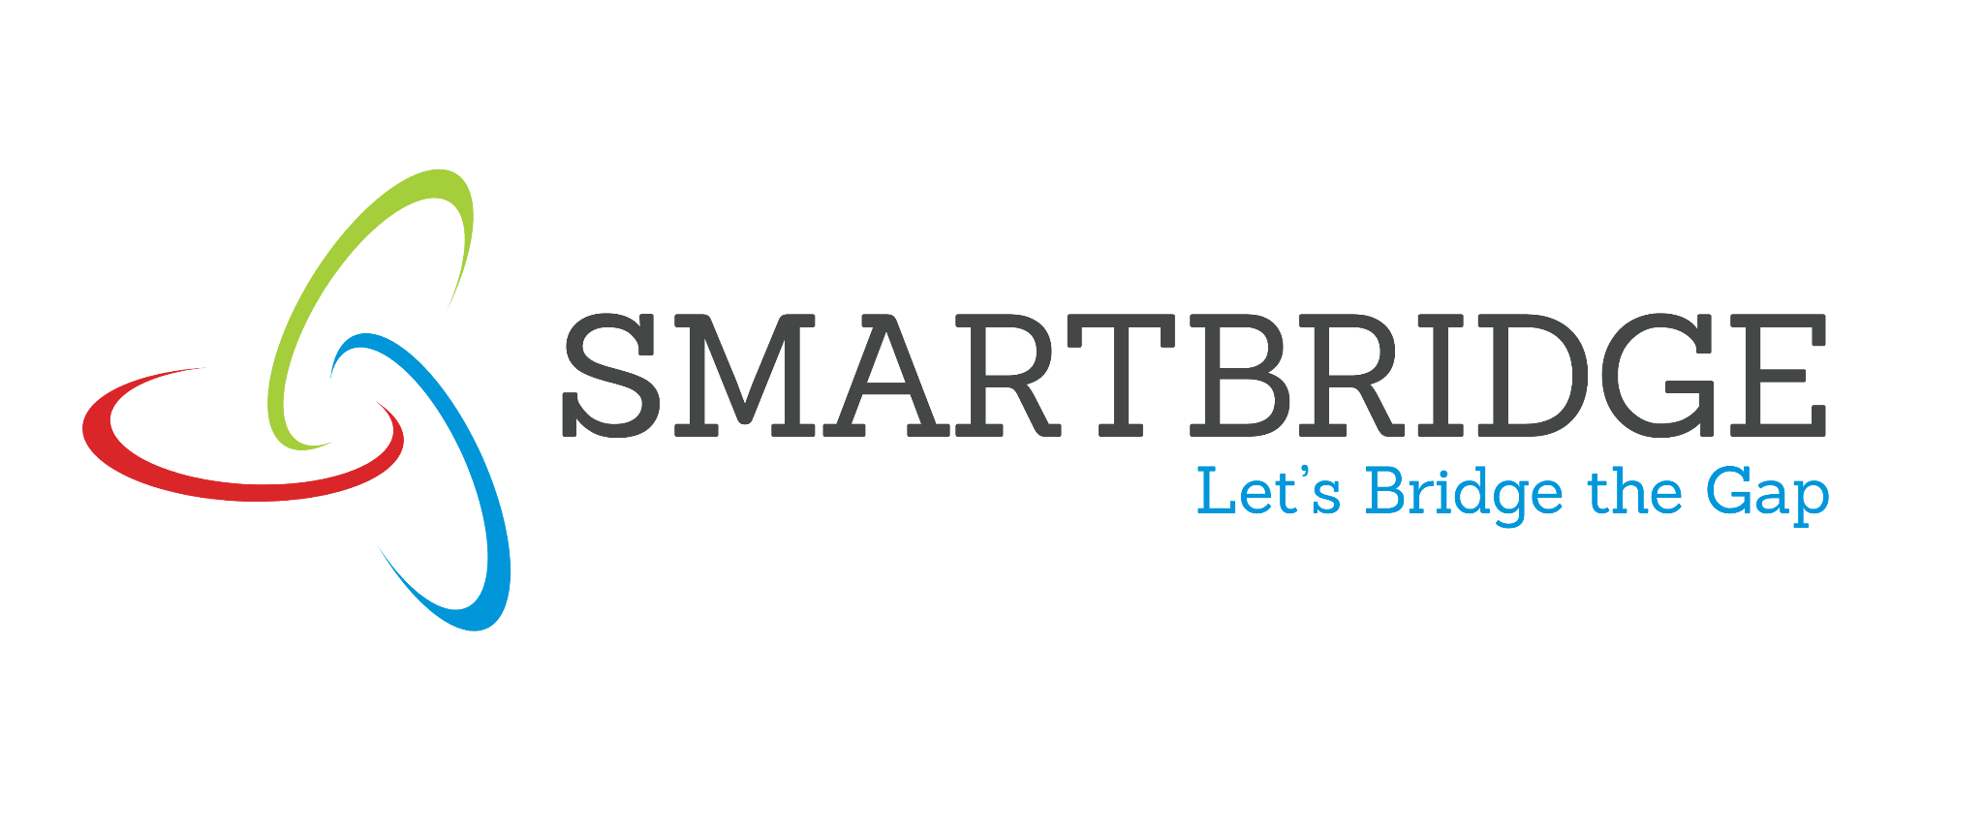 | 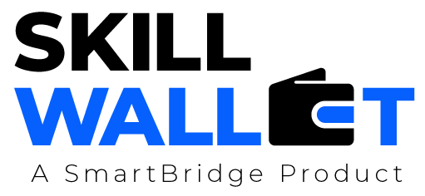
Customer Journey Map
Date | 06 July 2026
Team ID | Individual Project
Project Name | VBCUA – Voice-Based Concept Understanding Analyser
Maximum Marks | 2 Marks
Customer Journey Map
Map out the customer's experience stage-by-stage, capturing their actions, touchpoints, thoughts, and feelings, along with process ownership and improvement opportunities at each stage.
Phase of Journey | Stage 1: Prepare & Record | Stage 2: Submit & Analyze | Stage 3: Review & Improve
Actions  What does the customer do? | - Picks a topic to practice from the list.  - Reviews the reference explanation.  - Records a spoken explanation of the topic. | - Uploads the audio recording to VBCUA.  - Clicks “Analyze” to start evaluation.  - Waits while the pipeline processes the recording. | - Reviews scores, waveform, and AI feedback.  - Downloads the PDF evaluation report.  - Checks the dashboard for progress over time.
Touchpoint  What part of the service do they interact with? | - Topic selection dropdown.  - Reference explanation panel.  - Microphone / voice recording app. | - Audio file uploader.  - “Analyze” button.  - Loading/progress spinner. | - Results screen (scores & feedback).  - PDF download button.  - Dashboard tab and history table.
Customer Thought  What is the customer thinking? | - “Which topic should I practice today?”  - “I hope I can explain this clearly.”  - “Will my recording be clear enough?” | - “I wonder how accurate this scoring will be.”  - “How long will the analysis take?”  - “Was my explanation actually correct?” | - “Did I really understand this concept?”  - “What exactly should I improve next time?”  - “Am I getting better with practice?”
Customer Feeling  What is the customer feeling? | Slightly nervous, but motivated to practice. | Curious, with mild anxiety while waiting for results. | Relieved and encouraged by clear, actionable feedback.
Process Ownership  Who is in the lead on this? | Learner (self-directed topic choice and recording). | VBCUA system — Whisper, Sentence-BERT, and Librosa pipeline. | Learner, supported by VBCUA’s AI feedback and dashboard.
Opportunities  How can we improve this stage? | - Add real-time in-browser microphone recording.  - Let learners preview/trim their recording before upload. | - Show a live progress indicator during transcription.  - Allow batch upload for multiple attempts at once. | - Add topic-level analytics and cohort comparisons.  - Send email/notification when a report is ready.

